Robot V 1.29

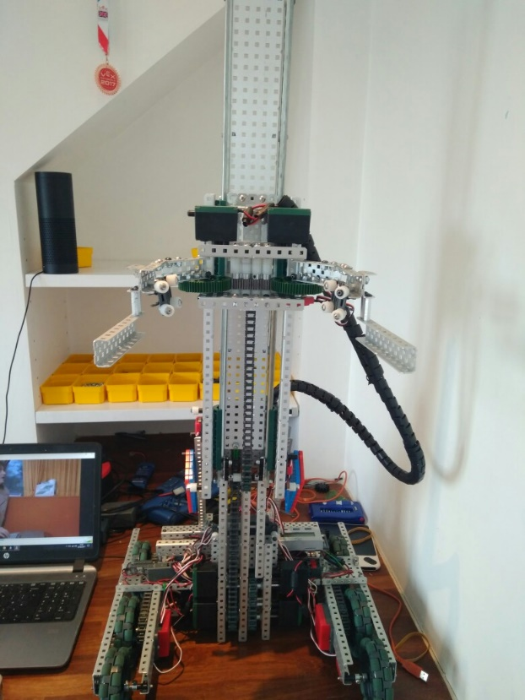

SPECIFICATIONS:

* 6 Motor HS drive
* Two drive chains
* 6 wheels
* Aluminium structure
* 4 motor lift
* Three stage lift
* 2 motor flip down claw

DIMENTIONS:

17.5” * 17.5” * 17.5 when not extended

**What needs to be changed:**

* Add mobile goal manipulator element to claw
* Add a way to hold up claw in the beginning.

By Robbie Buxton

04/8/2017 – 16:03

**Overview:**

After we called up our local vex parts supplier we found out that our vex field elements would not be arriving for at least another month. We decided to cut out a piece of paper in the exact dimensions of the mobile goal found in field appendixes to try and prototype a mobile goal manipulator. After building the extension to claw which we are certain will be able to pick up the mobile goal we realized that the claw was to big and was out of the size limit. After decide ding that making it smaller wouldn’t be a very good idea we decided to make our claw fold up at the begging. We did this using a hinge. We now need to find out a way to hold the claw up in the beginning.

**WHAT HAS BEEN CHANGED:**

* Added mobile goal manipulator
* Made the claw flip down